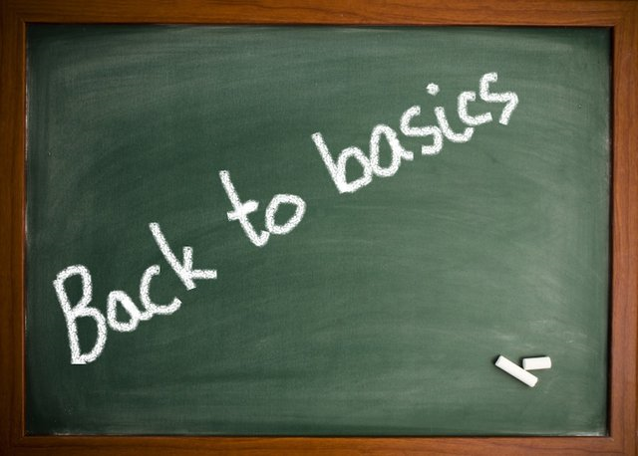
At lesson end put all resources away, tidy and straighten desks and chairs
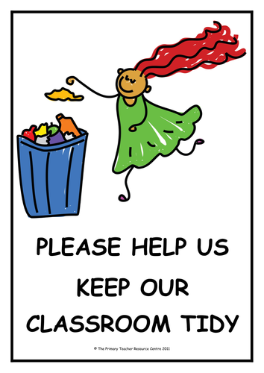
Listen!
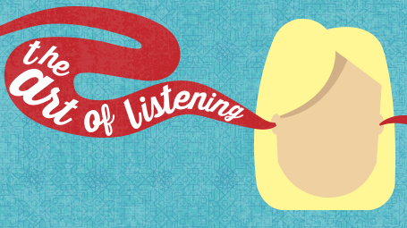
Have travel pass, lunch money/packed lunch, appropriate clothing for working outside
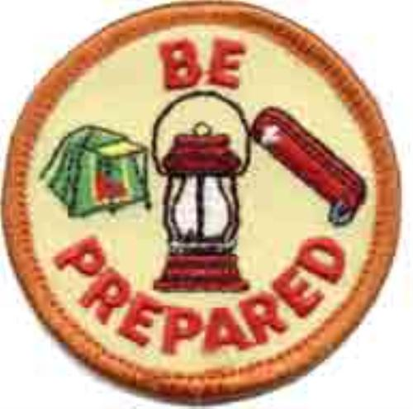

Wear your ID at all times
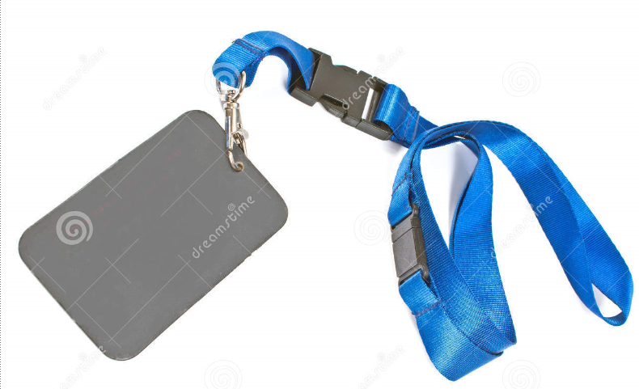
Respond clearly to register when called
Sit down and respond to the ‘Good Morning’ greeting
Take off coats and leave in designated space
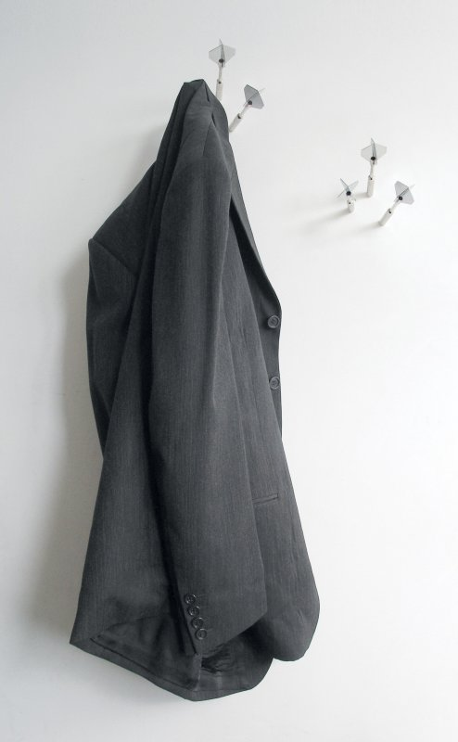
Arrive on time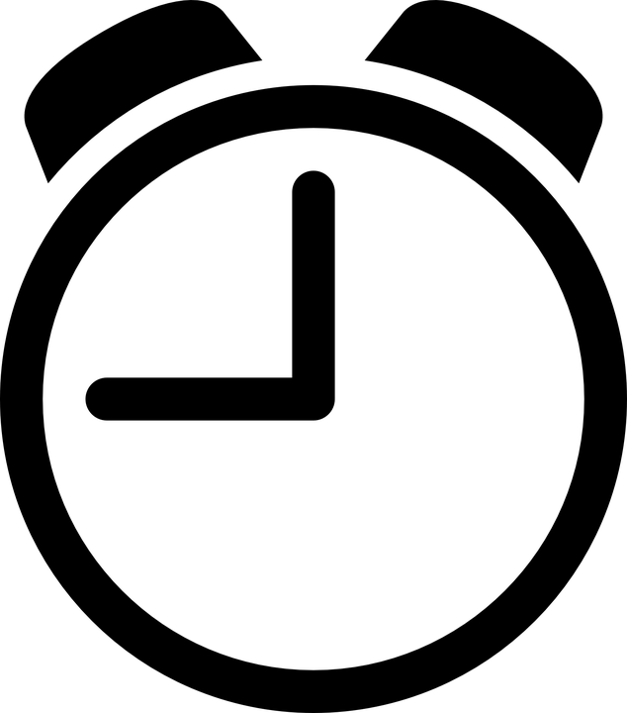

- Arrive on time to class
- Take off coats and leave in designated space
- Sit down (teacher not to start until everyone is settled)
- Respond to ‘Good morning’ etc greeting
- When register is called, answer clearly
- ALL students to wear ID (teacher to check all individuals)
- All students have (as appropriate)
    - Travel pass
    - Lunch money/packed lunch
    - Appropriate clothing for weather if working outside (teacher to check)
- Listen when teacher is talking
- Put all resources away towards lesson end (clear desk principle)
- At lesson end, students to straighten tables, push chairs underneath

